AP LAB - 1

NAME: SHEEFA NAAZ

ROLL NO.: 2128085

SECTION: CSSE 2

DATE: 27-07-2023

TOP 10 TOOLS USED FOR DATA ANALYTICS

- PYTHON

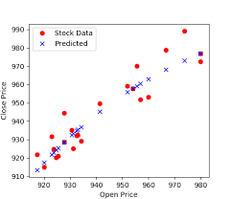

- Python is one of the popular tool used for data analysis.
- Python has many libraries that can help to extract data and derive insights from data.
- It has libraries like pandas, numpy, matplotlib which can help us to store data in csv format, visualize using charts, graphs and perform manipulation operations on data.
- Other than these, python provides numerous libraries and it is very easy to use them.
- It is important to know python language to implement all these libraries efficiently.

- TABLEAU

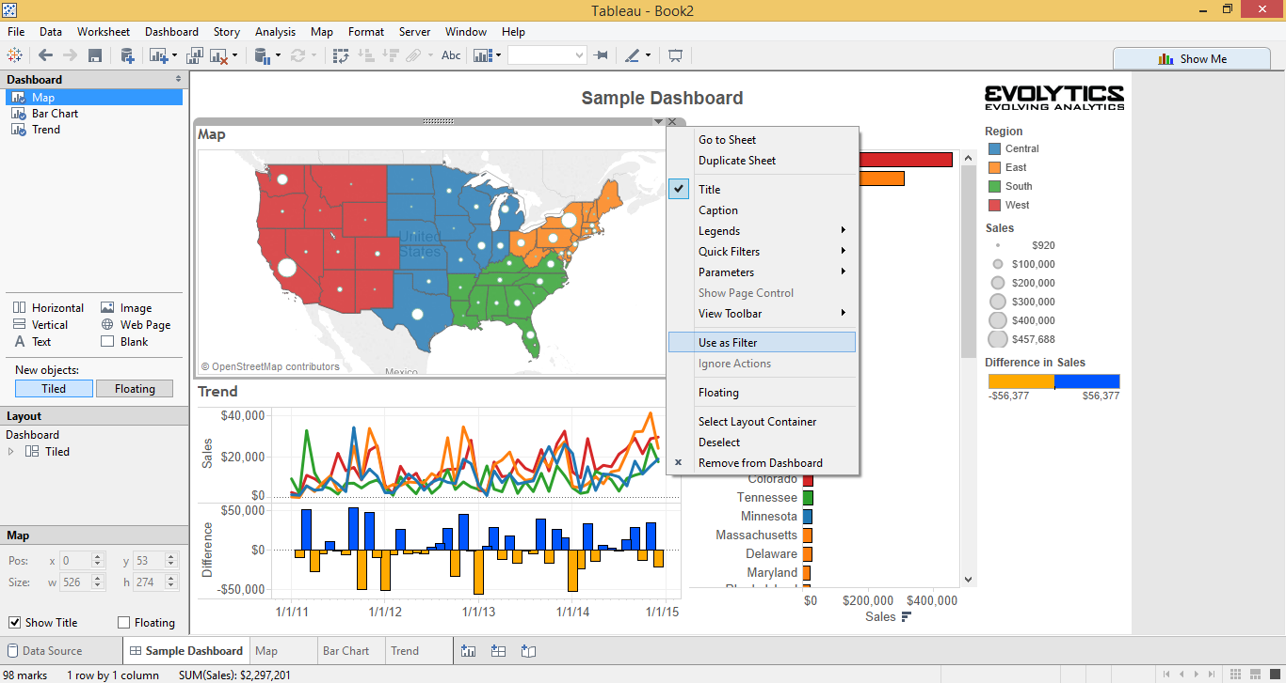

- It is one of the popular tools which helps us to visualize the big data easily.
- You do not need to know programming/coding. You can still use this platform efficiently.
- It helps to create the dashboards for data analysis and supports data in various formats.
- Huge amount of data can analysed easily with the help of visualization tools and insights can be derived for the business decision taking.
- It supports table, bar chart, graphs, maps.

- MICROSOFT EXCEL

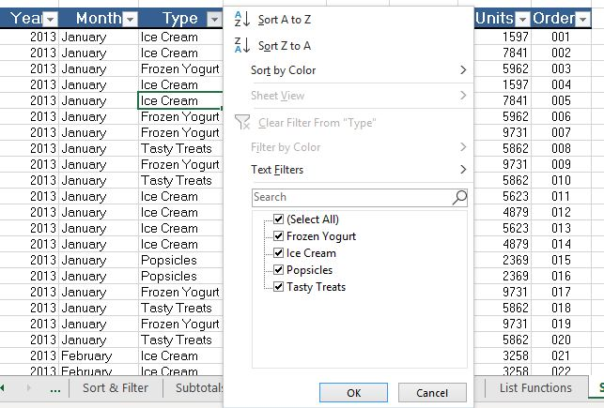

- Microsoft excel is very efficient, popular tool used by data analytics and business analytics.
- It was developed by Microsoft.
- It stores large amount of data in a structured format, helps in visualization too.
- We can perform various operations on the data for analysis and derive insights.
- It can processed our data like data cleaning, and answer our query.

- APACHE SPARK

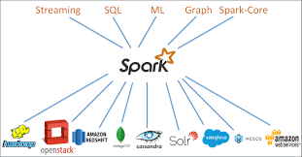

- It can process the big data easily. It supports real-time data streaming and provides many advanced analytics tools.
- It is efficient and very fast.
- It can be easily integrate with Hadoop and supports SQL queries.
- It supports various languages and is dynamic in nature.
- It is used friendly .

- SAS

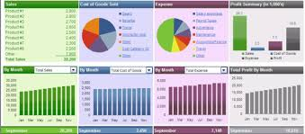
- Its full form is “Statistical Analysis System”.
- It is one of the tool used for data analytics of large amount of data I.e big data easily. Its syntax is easy to use and learn. But it is difficult than R and not open-source.
- It helps in visualization which help in deriving insights from the data.
- Here it is easy. It also provides data security and SAS customer support.
- It lacks representation of data in graph format and data mining is difficult

- POWER BI

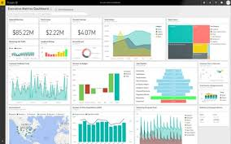
- It is a advanced tool used for data analysis of large data from any source and supports various formats.
- It has the feature of future forecasting which helps to make decision without loss of time and money.
- It provides drag and drop feature which make visulaization easy.
- Easily create a charts, graphs and metrics.
- Its dashboard helps us to derive insights from which we can take many data driven decisions.

- RAPID MINER

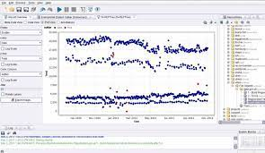

- It helps in data analysis and data mining from big data.
- It also supports drag and drop feature which make it easy to use. It supports many databases like oracle, nosql.
- It also helps in predictive analysis which helps to make various business decisions.
- It has numerous tools which help to statistically analyse our data.

- SPLUNK
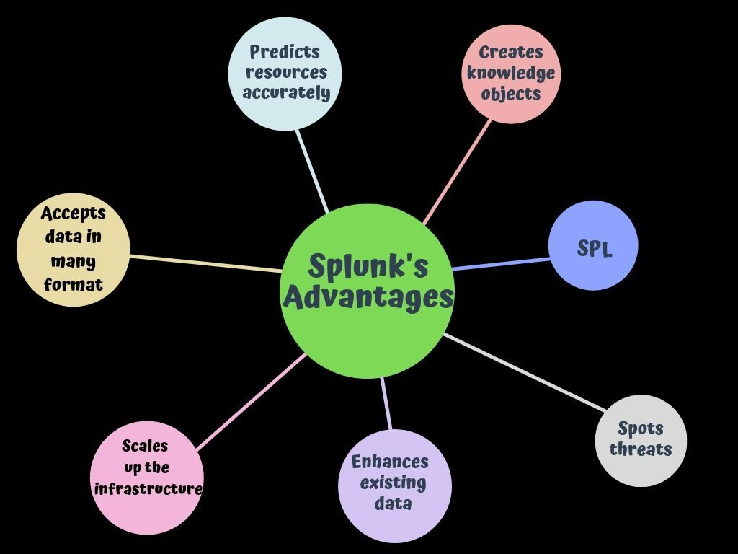
- It is a one of the powerful tool used for data analysis.
- It has dashboard and reports which makes decision making easy. It will reduce the risk of failure or faults in future of project/system.
- We can make unorganised data derive insights for taking business decisions.

- TENSORFLOW
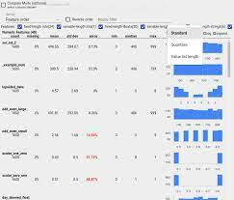
- It is a programming tool with the help of which we can visualize the data and perform operations on our data.
- It helps us to make data store in tensor data types.
- We can perform numerical operations on numerical data with the help of libraries of tensorflow.
- It is popularly used in deep neural networks for making AI.
- It is an open source platform.

- KNIME
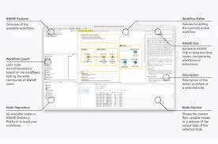

- It is an alternate to microsot excel. KNIME is written in Java language.
- If you want to use KNIME, you do not require the knowledge of coding.
- It provides a visual interface and is easy to import, clean, visulaize the data. It can automate various processes.
- Makes it easy take decisions.

R PROGRAMMING LANGUAGE ADVANTAGE

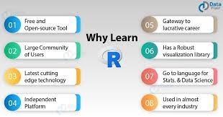

- R is a popular programming language next to Python for statistical modeling and analysis of large data i.e Big Data.
- R’s syntax is easy to learn and many data scientist uses it. It do not provide high security.
- It is a open-source language so it is feasible to use.
- R provides numerous libraries that can help us with the data analysis, data modelling and machine learning operations. It has many graph and plots libraries for visulizatuion. It do not support 3 d graphics.
- It helps us to make our unstructures data to structured form.
- It can also perform statistical operatons on our data.

